Parent Handbook
Updated February 2024

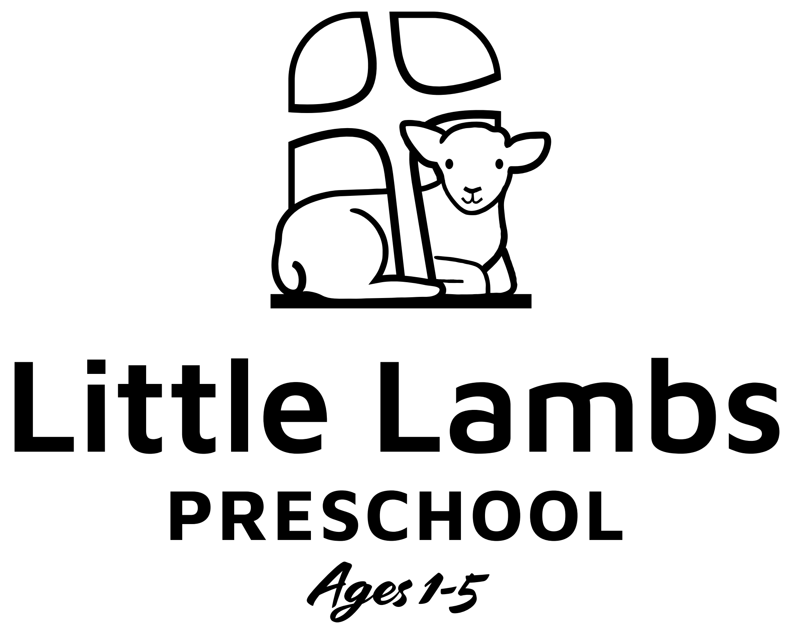

5210 North Roan Street, Johnson City, TN 37615
www.livingwordlutheran.com

Director- Cassi Chaffin
(423) 426-6929
littlelambsjc@gmail.com

Dear Parents/Caregivers:
Thank you for choosing Living Word Lutheran’s Little Lambs Preschool to care for your child. The purpose of our program is to extend the ministry of Living Word by providing care, education, and development opportunities in a Christian environment where each child can reach his or her greatest potential and by providing a program of ministry and outreach to the families of children enrolled.
We appreciate the trust you have bestowed upon us, and we will do our very best to exceed your expectations. We are excited that your child will be joining us for many fun-filled learning opportunities and look forward to getting to know your child as an individual and your family as a whole!
The policies outlined in the handbook are designed to help us provide a safe and consistent environment for your child. Please read them carefully and let us know if you have any questions or concerns.
Living Word Little Lambs Preschool is a non-licensed preschool program according to state regulations. The program is exempt from licensing due to the number of hours and number of days the program is open each week.

Children Served:
Our program is open to children age 1-4/Pre-Kindergarten.

Hours: We are open from 9:00am – 2:00pm Tuesdays and Thursdays. The director will provide a calendar of the days we are in session. Typically, three sessions are held each year (August to December / January to mid- May / late May to late July).

Admission and Registration:
Little Lambs charges a $25 one-time registration fee per family. Applications may be picked up from the church or will be mailed upon request. If all slots are full, then the child will be placed on a waiting list and be notified as soon as a space becomes available. Once your child is enrolled, there will be a $50 supply fee per semester (due in August and January).

Records:
Each child’s file must contain the following information before the child will be admitted to the program:
- Registration application
- Registration fee of $25
- Up-to-date immunization records
- Emergency information where parents can be reached, as well as names and telephone numbers of other authorized individuals in case parents cannot be reached.
- All forms must be updated yearly.
Daily Routines and Activities:
We feel that the most important job of our program is to teach the children about Jesus and his love for us! We believe that what young children need is to learn is best accomplished through play and responsive, nurturing care from adults. Activities are designed to be age-appropriate and balance a variety of both structured and unstructured time throughout the day.
The children will have the opportunity to participate in a Little Lambs Christmas program and a Spring Program/Graduation; teachers will provide you with dates and information.

What to bring to preschool:
- We try to go outside each day. Please bring appropriate clothing for your child.
- All children should have a set of spare clothing and footwear if available. Please put them in a gallon Ziploc bag clearly identified with your child’s name.
- Children in diapers need a supply of diapers and wipes. Please label both with your child’s name. Additional changes of clothes may be helpful.
- Children who are potty training need to have a supply of pull-ups and wipes. Also diapers for nap time in the one- and two-year-old room. Additional changes of clothes may be helpful. Please see our potty-training policy below.
- Children in the one- and two-year-old rooms have nap/rest period after lunch. Please provide a mat and blanket. Remember to take home and launder each week.

Parent Participation:
Staff members of Little Lambs Preschool recognize the importance of effective parent-teacher partnerships in serving children. In order to be successful, these partnerships must include honest and ongoing communication with families and respect for individual differences in values and priorities.
We are committed to frequent communication and encourage active parental participation in the care of their children. Methods of communication may include informal conversations with teachers at the beginning or end of each day, reports on daily activities, and parent/teacher conferences as needed or requested. We also welcome parents into the program at any time throughout the day.

Guidance Techniques:
Positive guidance techniques will be used with each child and time-out will be used only as a last resort in a manner that will not shame or embarrass the child.
Examples of positive guidance techniques include telling the child what to do rather than what not to do; redirecting the child to an area where play would be more positive; and substituting activities that may produce problems for the child for ones that are more positive for the child.

Tuition/Fees:
Tuition: $150 per month (first child), $130 per month (second child), $110 per month (third child)
Registration: $25/family to be collected with new enrollees
Supply fee: $50/child in August and January
Tuition is due on the first day of each month. Please speak with the director to make arrangements if tuition is not paid by the 10th of each month. A $10 per week late fee may be charged until payment is made.
Please note that we charge the same fee each month even though each month may have a different number of sessions. We did this to make it easier for parents to pay the same tuition monthly by taking the total number of sessions and averaging the cost over the entire year.
Also note that tuition fees may be increased at any time. We operate on a very tight budget and do our best to keep costs down.

Snow Policy/Inclement Weather:
Little Lambs will follow the snow schedule of Johnson City schools. If Johnson City schools are closed, Little Lambs will also be closed. If Johnson City schools are on a 1- or 2-hour delay, Little Lambs will be open at 10:00am. We are unable to provide refunds for days closed; at the director’s discretion alternate day(s) may be offered to make up for lost days.

Arrival and Departure Times:
ALL church doors will be locked daily except for the following times:
Drop-Off 9:00am – 9:30am Pick-Up 1:50pm – 2:15pm
Children will not be permitted in the classrooms before the opening time of 9:00am and must be picked up by 2:00pm each day. There is a $1.00 per minute charge for pickup after 2:00pm. Teachers will hand out tardy slips with warnings or charges for late pickup.
Children will only be released to responsible persons who have been listed on the child’s enrollment form. Photo identification will be required to enter the program area if the person is not personally known. Continual instances of late pick-ups could result in the dismissal of your child from the program.

Attendance:
Children are encouraged to attend each Tuesday and Thursday. Teachers have many fun and educational learning opportunities planned for the children and are prepared to teach them each day.

Potty Training:
Potty training is a partnership between parents and caregivers. It cannot be successful for the child without a commitment from both parents and caregivers. We encourage parents to discuss potty routines and readiness with their child’s teacher.
Staff will assist with potty training no earlier than 18 months of age since a child’s nerves and muscles that control bowel and bladder functions do not mature until 18-24 months of age. Potty training will be done in collaboration with parents who are potty training at home. Readiness for potty training requires two thing which must occur together:
- Physiological ability to control bladder and/or bowel movements.
- Desire and willingness on the part of the child
It is also our expectation to have children using pull-ups with few accidents in the three-year-old classroom. To accomplish this takes time on the part of parents and caregivers. Please feel free to discuss strategies with your child’s teacher or the program director.
Parents will be asked to provide pull-ups and extra clothing/footwear for children who are potty training. Staff should place soiled clothing in a plastic bag for parents to take home and wash.
Staff will NEVER put a child on the potty unless the child is willing. Children will be asked to use the potty on a regular basis throughout their time in preschool.
Behavior Policies:
- Biting Policy – We understand that some degree of biting is normal during early childhood years. We will not, however, tolerate excessive instances of biting. If a child bites twice in one day, parents will be called to come talk to the child and if it happens again the same day, parents will be asked to pick the child up immediately. Excessive biting could possibly lead to dismissal from the program.
- Excessive Behavior Issues: Little Lambs will not tolerate hitting, kicking, spitting, or biting staff or other children while in our care. If a child is observed to exhibit excessive behavior issues, parents will be notified and a parent – teacher conference will be held. Parents may also be asked to observe the child in the classroom; it is important when observing not to be interacting but just watching your child’s behavior in the classroom. Because the safety of the children and staff of the program are of utmost concern, we reserve the right to suspend and/or dismiss any child from the program due to excessive behavior issues. Other behaviors that are considered disruptive are requiring constant attention from staff, disrespects people and materials in the program, consistently disobeys classroom rules and refuses to take direction from staff, and using verbal or physical activity that disrupts activities of the group.

Guidelines and strategies to respond to undesired behavior:
- Remove the child from the situation and clearly explain the unacceptable behavior. Explain what behavior is acceptable and offer forgiveness that is theirs in Jesus and how to apologize for their actions/behavior.
- Encourage children to use their words when having a disagreement and allow children time to explain their side of the disagreement. Facilitate children in their attempts to settle their own disputes providing a model of acceptable behavior.
- Intervene and redirect behavior when children become frustrated with an activity. Offer praise to children who model acceptable behavior. Encourage appropriate behavior using praise, recognition, and warning when negative behavior occurs.
- Remove the child and follow guidelines in #1. A quiet time out spot can be used based on the child’s age.
- Teachers should discuss behavior strategies with the director before implementing new techniques. An incident report can be completed if both the teacher and director believe the parent(s) should be notified of undesirable behavior. A copy will be placed in the child’s file.
- The teacher will give the incident report to the parents at pickup. Every attempt should be used to explain the report apart from the other parents picking the children up.
- The director may schedule a conference with the parent to discuss incident reports or ongoing behavior issues. The director may request input from the paster on appropriate strategies to us in dealing with the child and /or parents.
- If the above actions are unsuccessful in correcting behavior, the child may be removed from the program. The director will discuss any such removals with the Paster and Steering committee prior to initiating removal. Parents will receive written notice as well.

Reporting Suspected Child Abuse/Neglect:
The staff members of Little Lambs have a legal and ethical responsibility to report any reasonable cause to suspect that a child is being neglected, abandoned, exploited, or abused immediately to the statewide 24-hour child abuse hotline at (877)237-0004 for immediate response and assistance.

Withdrawal from the Program:
If your child will no longer attend the program, we request notification be given at least two weeks before the child’s last day. Parents must sign a termination statement and/or give written notice. Also, a bill will be given for at least two weeks from the date of the termination statement is signed.

Health:
- Parents are asked to sign a release for emergency medical treatment. Should an emergency arise, the director or teacher will contact parents and consult with the child’s pediatrician if necessary. In the event of complications, the child will be taken to the hospital.
- Any child with diarrhea/vomiting or fever of 100 degrees or above will be classified as “sick” and parents will be asked to pick up their child from Little Lambs. Children must be free of diarrhea or fever for 24 hours before returning to the program.
- No medications will be given while your child is in our care. Please administer medications while your child is in your care.
The only exception to the rule is for children whose parents have supplied EpiPens because of an allergy concern. Our staff will inject these into the child should an allergic reaction be observed. Please see the director for the appropriate paperwork.
- Children need to remain at home until symptoms and fever free for 24 hours.
- Children who are given an antibiotic for treatment of upper respiratory illness, etc. need to remain at home until on the medication for at least 24 hours. In addition, the child needs to be free of diarrhea, vomiting, or fever for 24 hours.

When is a child too sick or contagious to be brought to preschool?
In order to protect the children, we have set up some guidelines regarding illnesses. If at any time the director of staff members feel that a child is too sick or contagious, the child will not be able to attend. If a child becomes ill while at preschool, parents will be immediately notified. Children are to be kept at home if they have:
- Severe cold and fever, sneezing, nose drainage, and coughing
- Temperature of 100 degrees or higher in the morning
- Conjunctivitis- An eye infection commonly known as “pink eye.” The eye is generally red with some burning and yellowish drainage.
- Bronchitis- This can begin with hoarseness, cough, and a slight elevation in temperature. The cough may be dry and painful, but it gradually becomes productive.
- Rashes that you cannot identify or have not been diagnosed by a physician.
- Impetigo-Begins- Red pimples on the skin, which frequently become small vesicle surrounded by a reddened area. When the blister breaks, the surface is raw and weeping.
- Diarrhea- Watery or greenish bowel movements that look different and are much more frequent than normal.
- Vomiting- More than the usual “spitting up”.
- If a doctor diagnoses a communicable disease, please ask for a note providing the date the child may return. The health department sets rules for reporting and the length of time people need to remain out of group setting.

Head Lice:
Children with active head lice may not attend until completion of appropriate treatment. Please consult with your family physician or the health department for treatment guidelines. Educational materials are available on the internet. Since many products are toxic insecticides, please read and follow package directions before using them on your child. Head lice can be removed from cleaned and brushed hair using a louse comb available at most drug stores and in treatment kits. Removal of lice and nits can be painful so start with clean, well brushed hair to minimize the discomfort. Residual nits ¼ up the hair shaft usually do not contain eggs and are harmless.

Welcome to our program. We hope it will be a great experience for you and your child. Do not hesitate to talk with the staff or program director if you have any questions of concern.

